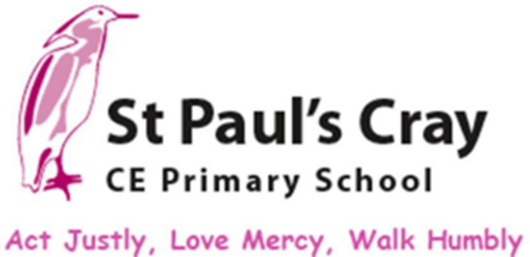



Spirituality Policy

Approved by: | Liz Bennett/ Faith Committee | Date: | November 2024
Reviewed on: | September 2024 | Next review due: | September 2026
Act Justly, Love Mercy, Walk Humbly
Spirituality Policy
Introduction
At St Paul’s Cray, all aspects of school life reflect a Christian ethos and this policy is based on Christian principles. We aim for all children to work together to live life in all its fullness, this includes their spiritual development.
What is it?
At St Paul’s Cray C E School, we believe it is important to provide all children with a range of opportunities to develop their spiritually. We believe that spiritual development may not be synonymous with Religious Education and Collective Worship and can be explored through many different curriculum areas.
As a school, we focus on the idea of 4 concepts of spirituality: self, others, world and beauty and beyond. Our starting point is our pupil’s own ‘Big’ questions about life and from this we plan a series of encounters (Windows) that open up the possibility of reflection (Mirrors). Finally, the children are given an opportunity to put into action what they believe and value (Doors).
Why is it important?
Christians believe that God became human and therefore Christians always strive to be the best they can possibly be. As educators and in accordance with the Equalities Act 2010, we want to help every child to be the best that they can be and have a duty to support the children to achieve this; part of the relationships to help children develop spiritually. At St Paul’s Cray, all aspects of school life reflect our Christian ethos through our vision and all policies are based upon this.
What do we aim to achieve for the children?
- For the children to become increasingly aware of the concept of self – the inner person and the way that this shapes an individual’s perception of themselves as a unique person. The children reflect on the relationship they have with their sense of being a unique person.
- The children become increasingly aware of the concept of others – a growing empathy, concern and compassion of how to treat others. The children reflect on how their values and principles affect their relationships with others.
- The children become increasingly aware of the concept of a physical and creative world – a growing relationship with beauty through the ability to respond emotionally to experiences of the wonder of the natural world and the results of human creativity. The children explore their understanding of beauty and the affect this has on their perception of and relationship with the world.
- The children become increasingly aware of the concept of the beyond – a growing relationship with the transcendental and the ability to explore experiences beyond the everyday. The children search for meaning in their very existence and their place in the greater scheme of things.
- The children develop an understanding of the beliefs and values of Christianity and the other world religions. The children are respectful of the beliefs and values of others.
- The children develop an understanding of the ethos of a Church school and the content, language and symbolism of the Christian faith as a way of understanding our meaning and purpose in life.
- The children develop the ability to question.
- The children develop their ability to express their thoughts, ideas, feelings and their beliefs.

How do we do it?
- We provide and plan for a wide range of opportunities for children to develop spiritually in all areas of the curriculum. In particular Religious Educations, English, PHSE, Science, Maths, topic, Art and Music.
- We provide and plan for a wide range of opportunities for the children to develop spiritually through worship: Key Stage worship, Year group and class worship.
- We also promote spiritual development opportunities through our wider curriculum, for example Black History Month, Friendship week, Charity days, Forest School and through other extra-curricular activities such as school drama productions.
- We provide areas for quiet reflection in school and in the outdoor environment.
- We provide opportunities for prayer, including silence and stillness.
- When planning for spiritual development we focus on 3 areas: Windows, Mirrors and Doors.

WINDOWS
Encounter – The Learning about life.

We give children the opportunities to become aware of the world in new ways, to wonder about life’s ‘Wows’ (things that are amazing) and ‘Ows’ (things that bring us up short).
MIRRORS
Reflection – The learning from life.

We provide children with time for REFLECTION. We give children opportunities to reflect on their experiences, to look inward and consider the big questions of life. In this they are learning from life by exploring their own insights and perspectives and those of others. Give emotional, physical and auditory space.

DOORS
Transformation – The learning to live by putting into action what they believe.

We give children opportunities to respond to all of this; to do something as a means of expressing, applying and further developing their thoughts and convictions. In this they are learning to live by putting into action what they are coming to believe and value.

This document supports this policy:
The Church of England Education Office – ‘Spiritual Development Interpretations of Spiritual development in the classroom – October 2019
https://www.churchofengland.org/sites/default/files/2019-11/2019-spiritual-development-interpretations-of-spiritual-developments-in-the-classroom.pdf

